Plan for assignment 1
Decomposition:
- Need to identify that all files are indeed present in the directory
- Examine each file to understand the contents
- Identify the primary key and foreign key in each table
- Confirm the relationship between each table:
Constructing : Use SQL then push to github repo, create readme
Evaluation as per assignment
BEGIN
use:
- Sed –n 1p eachfilename
Entities:
Create ERD
3. Use mysql to create database assignment
Then create tables mirrored on ERD then run queries to confirm data correct
1.hospitals.csv:
CREATE TABLE hospitals
(
hospital_id INT unsigned NOT NULL,
name VARCHAR (200) NOT NULL,
address VARCHAR (200),
size INT NOT NULL,
type VARCHAR (200),
accreditation_status VARCHAR (200) NOT NULL,
PRIMARY KEY (hospital_id)
);
2.doctors.csv:
CREATE TABLE doctors
(
person_id INT unsigned NOT NULL,
name VARCHAR (200) NOT NULL,
date_of_birth DATE NULL,
address VARCHAR (200) NULL,
role VARCHAR (200),
hospital_id VARCHAR (200) NOT NULL,
PRIMARY KEY (person_id)
);
LOAD DATA local infile "doctors.csv" INTO TABLE doctors FIELDS TERMINATED BY "," enclosed by """" IGNORE 1 LINES (person_id, name, date_of_birth, address, role, hospital_id);
3patients.csv
CREATE TABLE patients
(
person_id INT unsigned NOT NULL,
name VARCHAR (200) NOT NULL,
date_of_birth DATE NULL,
address VARCHAR (200) NULL,
role VARCHAR (200),
doctor_id INT (200) NOT NULL,
PRIMARY KEY (person_id)
)
LOAD DATA local infile "patients.csv" INTO TABLE patients FIELDS TERMINATED BY "," enclosed by """" IGNORE 1 LINES (person_id, name, date_of_birth, address, role, doctor_id);

4.prescriptions.csv
CREATE TABLE prescriptions
(
prescription_id INT unsigned NOT NULL,
patient_id INT NOT NULL,
doctor_id INT NOT NULL,
medication VARCHAR (200) NULL,
prescription_date DATE NOT NULL,
PRIMARY KEY (prescription_id)
);
LOAD DATA local infile "prescriptions.csv" INTO TABLE prescriptions FIELDS TERMINATED BY "," IGNORE 1 LINES (prescription_id, patient_id, doctor_id, medication, prescription_date);

TEST
- Print a list of all doctors at hospital id 3
SELECT person_id FROM doctors WHERE hospital_id = 3 NOTE this needs join
- Print a list of all prescriptions for a specific patient, ordered by presc date
SELECT * FROM prescriptions WHERE patient_id = 621 ORDER BY prescription_date
- Print list of all presc that doctor id 20 has written
SELECT * FROM prescriptions WHERE doctor_id = 20

- Add new pt : Rachael Dave to database and register with doctor_id 20
Info for Rachael Dave:
person_id,name,date_of_birth,address,role,doctor_id
Need to assign a person_id as I didnt use auto_increment in tables
Use : sed –n ‘$p’ patients.csv
INSERT INTO patients.csv (701, rachael dave, 1990-01-01, “1 Darent Club, WA 10465”, Patient, 20;
Check
SELECT * from patients WHERE person_id =701
Difficult so:
Amend all tables to include auto_ increment
ALTER TABLE hospitals MODIFY hospital_id INT UNSIGNED NOT NULL AUTO_INCREMENT;
Check: DESCRIBE hospitals
Retry new pt : Emma Long assigned to dr_id 20
INSERT INTO patients (name, date_of-birth, address, role, doctor_id) VALUES (‘emma long’, ‘1990-01-01', ‘1 Darent Club, WA 10465’, Patient, 20);
Check

5. Select the dr who did the most presc
This needs to join doctors and prescriptions table
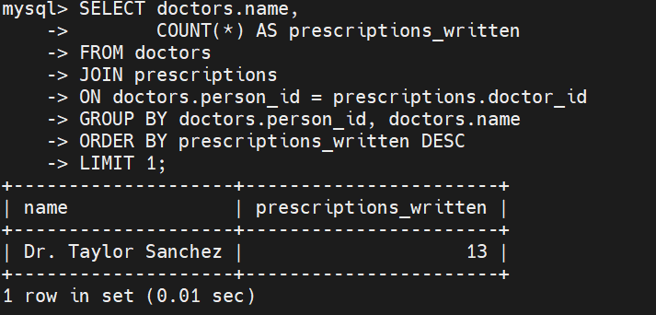
6. all drs at hosp with biggest size
Join drs and hosp using maximum size
